The simplest model of an epidemic involves three groups of a given population; they are called susceptible, infected, and recovered and so the model is called S-I-R. The model is too simple to be accurate in all details, but it does illustrate the dynamics of epidemics. I have used this model to calculate the evolution of these groups using reasonable values for the parameters for Australia.

In this model, two parameters dealing with the disease are recovery time and contact time. I choose a recovery time of 14 days (cited values are between 1 and 3 weeks) and a nationally averaged contact time of 4 times per hour (a guess). The calculation is for fraction of the population in the three groups with initial values being 100 infected (red), 0 recovered (green) and the balance susceptible (blue).
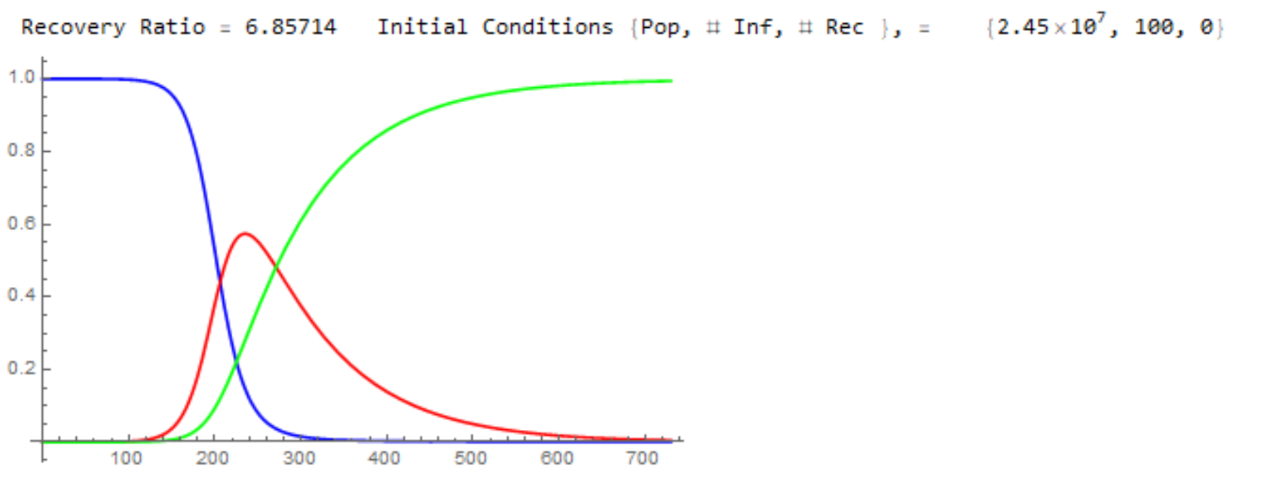

The horizontal axis is in days and the vertical is the fraction of the relevant population. We are currently at about the 50-day mark so not aware of the peak which comes at about 250 days when some 60% of the population is infected and the remainder split between the other two groups.

The early times appear flat because of the scale of the graph, but if you look more closely at any region it is growing exponentially. For example, expanding points in the region between 95 and 105 days the graph looks like the one below. The data points are red dots which are almost obscured by an exponential curve fit (the continuous green curve). The doubling time at the mid-point (100 days) is 11.4 days. This graph is similar to those in the news currently for countries not doing well (Italy, Spain, US and Australia, …)
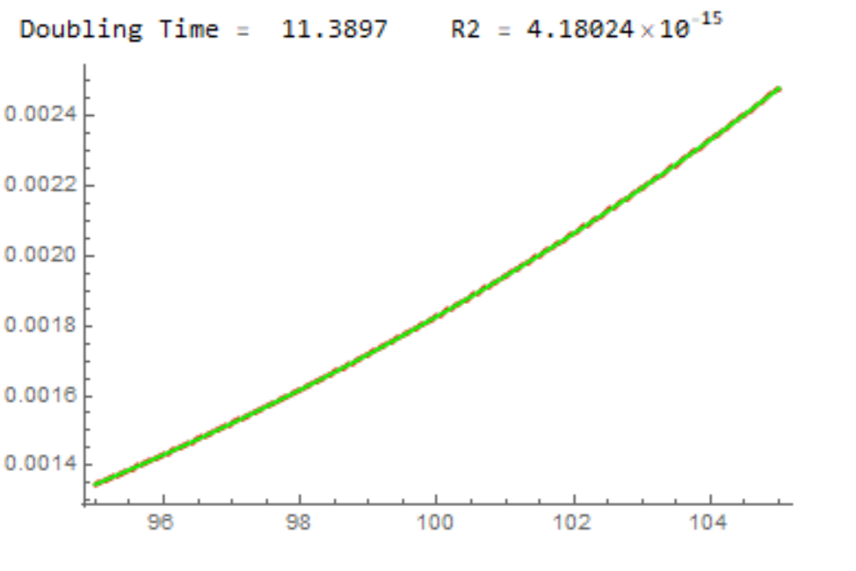
The first graph assumes that the infection rate remains the same throughout the epidemic. If a strategy to reduce the infection rate is adopted the peak of the curve drops but moves ahead slightly in time. The graph below is a result of halving the infection rate.
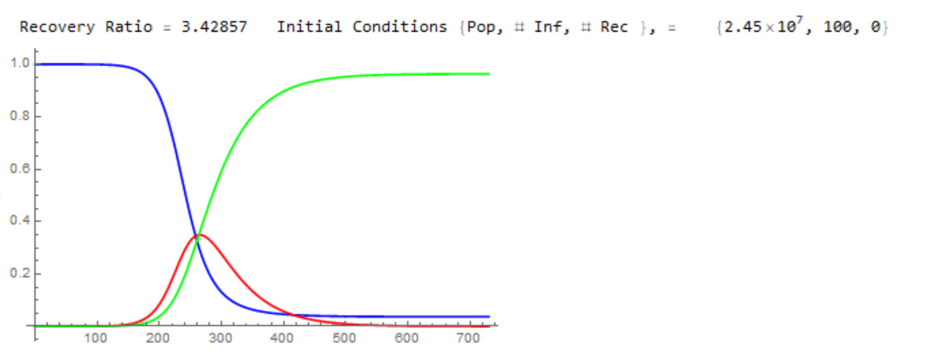
Once again, this simple model is only able to describe the general features of an epidemic. The 250 days to a recovery period should not be taken as a prediction, although recovery may well take months. And it does illustrate the effectiveness of strategies to reduce the infection rate.
Also, the model shows why epidemiologists are concerned when they see a disease with unknown characteristics appear out of the blue. The current corona virus migrated from animals to humans late last year and then began to propagate among humans who have no immunity to this particular disease. They know that the early flat part of the infected population curve could eventually grow rapidly out of control if steps are not taken early.

