Date | time: Tuesday 24th March; 6:45pm for 7:00pm
Chairperson: |  | NA |  |  |  |  | Speaker: |  |  | Presidents
Fellowship: |  | RC Rowville & Lysterfield |  |  |  |  | Speaker Minder: |  |  | NA
Furnishings:  Response: |  | NA  NA |  |  |  |  | Toast to Glades: |  |  | NA

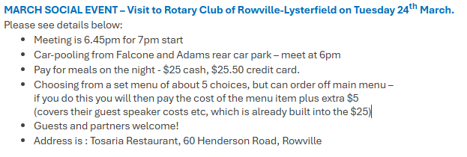

Birthdays
Nil

Anniversaries – Joining Rotary
Nil

Anniversaries – Wedding
Nil

Duties Tuesday 31st March
Chairperson: | Peter Brock |  |  |  | Speaker: | PDG Malcom Chiverton
Fellowship: | All |  |  |  | Speaker Minder: | Greg Adams
Furnishings:  Response: | Peter  Anna St Clair |  |  |  | Toast to Glades: | NA

Acknowledgement of Country and National Anthem
As per the Board meeting of 22 June 2022, the Club has agreed to
- Acknowledgement of Country once per month.
We would like to acknowledge the traditional custodians of this land on which we meet, the Wurundjeri people of the Kulin nations. We pay our respects to the elders past, present and emerging.
- National Anthem at Club Assemblies (Week 5) and special events.

